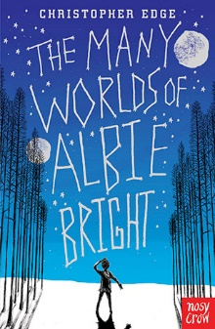
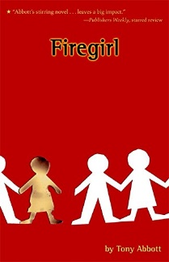
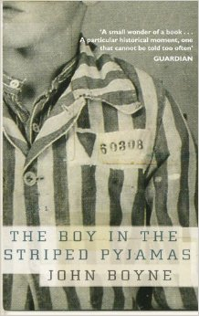
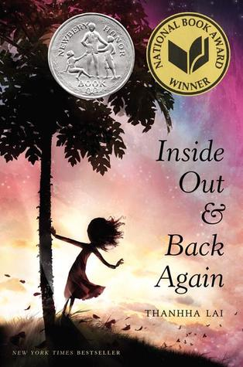
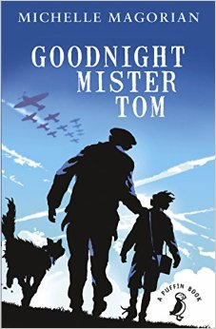
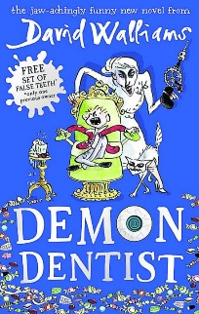
100 Books To Read In Year 5 and 6
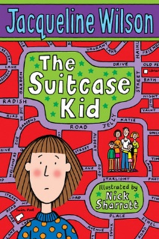
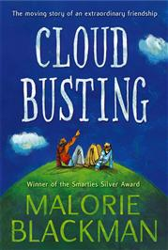
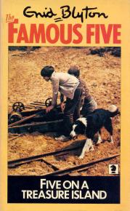
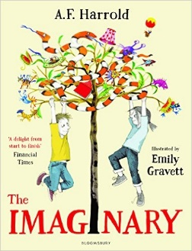
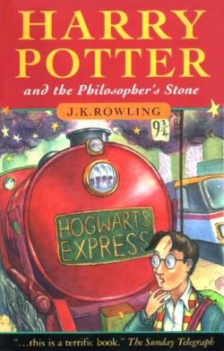
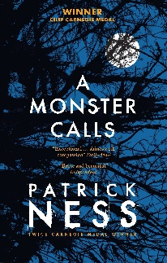
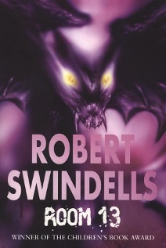
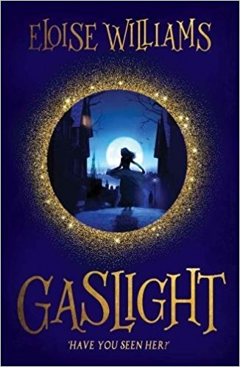
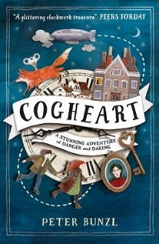
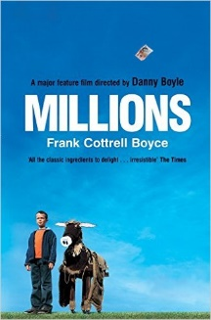
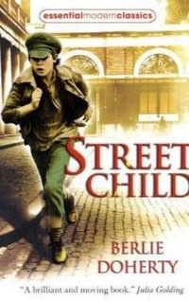
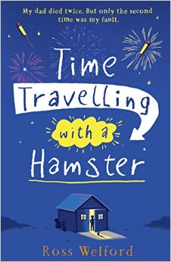
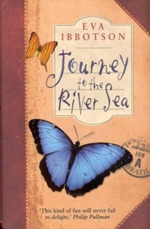
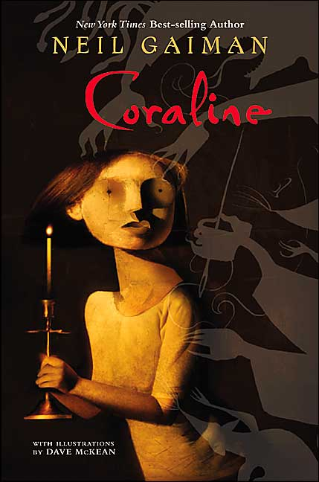
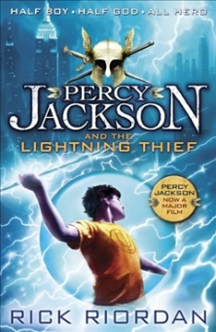
v
Cloud Busting
Malorie Blackman
Five On A Treasure Island
Enid Blyton
The Suitcase Kid
Jacqueline Wilson
The Imaginary
A F Harold
Harry Potter and the Philosopher’s Stone
JK Rowling
A Monster Calls
Patrick Ness
Room 13
Robert Swindells
The Many Worlds of Albie Bright
Christopher Edge
Firegirl
Tony Abbott
Gaslight
Eloise Williams

Cogheart
Peter Bunzl
Street Child
Berlie Doherty
Millions
Frank Cottrell-Boyce
Time Travelling With a Hamster
Ross Welford
The Boy in the Striped Pajamas
John Boyne
Percy Jackson and the Lightning Thief
Rick Riordan
Coraline
Neil Gaiman
Journey to the River Sea
Eva Ibbotson
Inside Out and Back Again
Thannha Lai
Goodnight Mister Tom
Michelle Magorian
Demon Dentist
David Walliams

