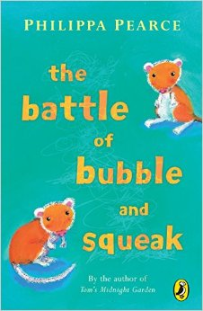
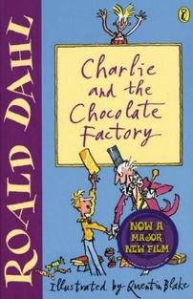
100 Books To Read In Year 3 and 4
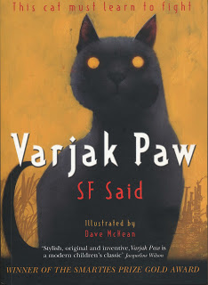
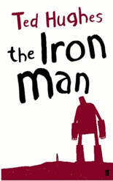
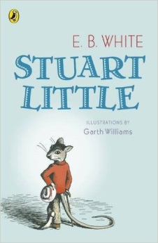
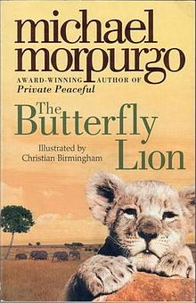
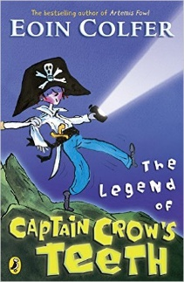
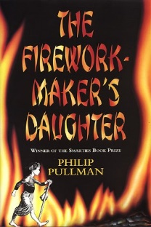
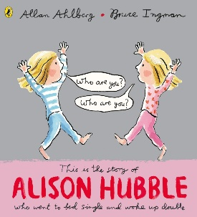
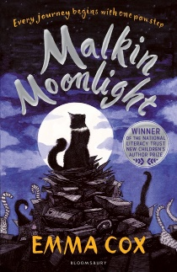
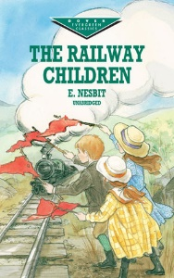
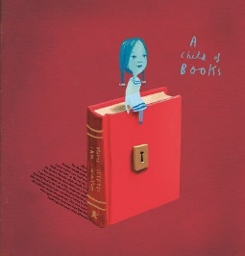
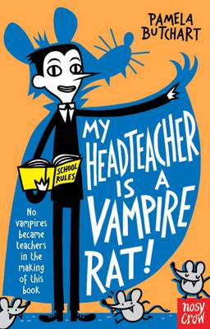
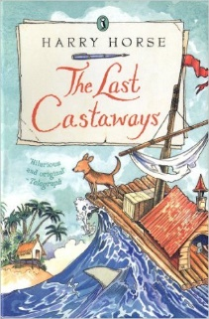
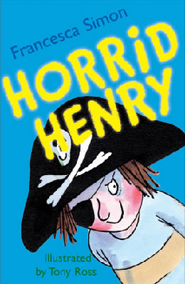
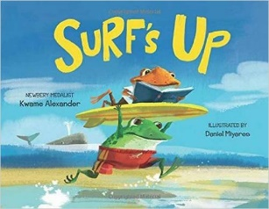
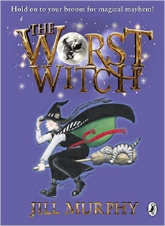
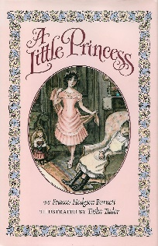
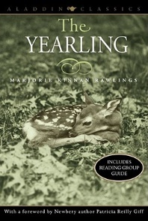
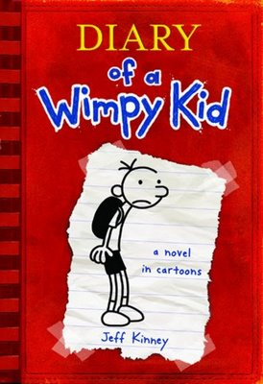
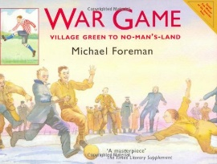
The Legend of Captain Crow’s Teeth
Eoin Colfer
The Firework-Maker’s Daughter
Phillip Pullman
The Battle of Bubble and Squeak
Phillips Pearce
Alison Hubble
Allan Ahlberg and Bruce Ingham
Malkin Moonlight
Emma Cox
The Railway Children
E Nesbit
Varjak Paw
S F Said
A Child Of Books
Oliver Jeffers
My Headteacher is a Vampire Rat
Pamela Butchart
The Last Castaways
Harry Horse
Charlie and the Chocolate Factory
Roald Dahl
Horrid Henry
Francesca Simon
Surf’s Up
Kwame Alexander
The Worst Witch
Jill Murphy
War Game
Michael Foreman
The Iron Man
Ted Hughes
A Little Princess
Frances Hodgson Burnett
The Yearling
Marjorie Kinnan Rawlings
Diary Of A Wimp Kid
Jeff Kinney
Stuart Little
E B White
The Butterfly Lion
Michael Morpurgo

